Using methods of machine learning for automatically predicting FFR from coronary CT angiography 1

Method 3

Data Analysis 6

The developing of the ML model 10

# Using methods of machine learning for automatically predicting FFR from coronary CT angiography

Abstract

The computational fluid dynamics (CFD) approach has been frequently applied to compute the fractional flow reserve (FFR) using computed tomography angiography (CTA). This technique is efficient. We developed the platform using the deep learning technique to calculate the FFR value out of CTA images in a short period of time. This study is to evaluate the platform using the deep learning technique to calculate the FFR value from CTA images as an efficient method.

A single-center, prospective study was conducted and 63 patients were enrolled for the evaluation of the diagnostic performance of the platform. Automatic quantification method for the three-dimensional coronary arterial geometry and the deep learning based prediction of FFR were developed to assess the ischemic risk of the stenotic coronary arteries. Diagnostic performance of the platform was assessed by using wire-based FFR as reference standard. The primary evaluation factor was defined by using the area under receiver-operation characteristics curve (AUC) analysis.

Introduction

Screening the functional significance of the coronary artery disease is critical to the medical decision-making.However, there is a gap between the increasing population of the coronary arterial disease (CAD) and the application of clinical screening for preventing the major adverse clinical events (MACE). This is partially due to the invasive manner of the ‘gold standard’ examinations, such as invasive coronary angiography (ICA) and fractional flow re-serve (FFR). Non-invasive computed tomography (CT) has showed superior diagnostic performance in detecting the anatomic significance of coronary arterial stenosis computed tomography angiography (CTA) and CT perfusionand hemodynamic significance using computed fluid dynamics (CFD) analysis. Despite the progressions in medical imaging technique and computation-aid diagnostic assistance have facilitated the non-invasive functional assessment of CAD, the time-expense and excessive technical interferences have hindered the application in clinical routine. Therefore, efficient noninvasive calculation of FFR should be included in clinical routine.

Machine learning (ML) has been applied for accelerating the diagnostic differential process. By characterizing medical data and developing interpretations towards outcomes, ML could model the direct connection between the raw data and medical decision-making indices to relive the differential process from the massive data miningand heavy computation expense.Previous studies showed that ML algorithm is capable to screen the lymph node metastases in breast cancer fifteen-fold faster than experience pathologist, and to shorten the time-span for diffusion MRI data processing by twelve-fold faster.CT-derived FFR in addition to image acquisitions may take 30 min to 4 h,mainly due to time-consumed procedures of solving governing equations derived by discretization of the partial differential equations with large-scale elements in the arterial geometries,[14] The alternative approach could replace the procedures of solving governing equations by using ML algorithm to model the connections between complex representation of the coronary geometries and the subsequence variations of pressure distribution.

In this study, we presented a new deep learning approach, to model the connection be-tween CT image and calculated FFR. The ML algorithm was constructed to interpret the physical properties of the blood pressure distribution in the patient-specific coronary arteries. Accordingly, we aim to evaluate the diagnostic performance of the platform in predicting the ischemic risk of the coronary arterial stenosis using ICA-FFR as a reference standard.

# Method

Patients

This was a prospective, single-center, self-control study evaluating the diagnostic performance of coronary arterial ischemia assessment using the platform with ICA-FFR as reference standard. Data for evaluation of the platform were retrieved from England Hospital. The study was approved by the region ethic committees at the participating hospital, and patients provided written in-formed consent. The platform was conducted at core laboratory (Keya Medical technology, China). Evaluation of the diagnostic performance was performed in the blind manner to the ICA-FFR measurement.

Patients who underwent non-invasive CT with documented FFR within a maximum interval of 30 days were included following the criteria: age between 18 to 75; provided with inform consent; CTA was performed in-hospital and fulfilling the quality check; agreed with CTA-FFR test and ICA-FFR measurement; at least one lesion (30% to 90% degree of stenosis) was presented in the coronary arterial branch with diameter larger than 2 mm; and agreed to follow the designed protocol. Patients were excluded for not adequate for ICA and FFR measurements; previous coronary artery bypass grafting (CABG) or percutaneous coronary intervention (PCI) or other kinds of cardiac surgeries; myocardial infections within 30 days before/after CTA, tachycardia or significant arrhythmia; body mass index (BMI) > 35 kg/m2; acute symptoms; and other factors that made the patient not adequate for the study. Drop out criteria was effective when drop out request was made by enrolled patient; severe adverse events; CTA images failed quality check; and other factors for the administrator decided that the patient was inadequate for the study.

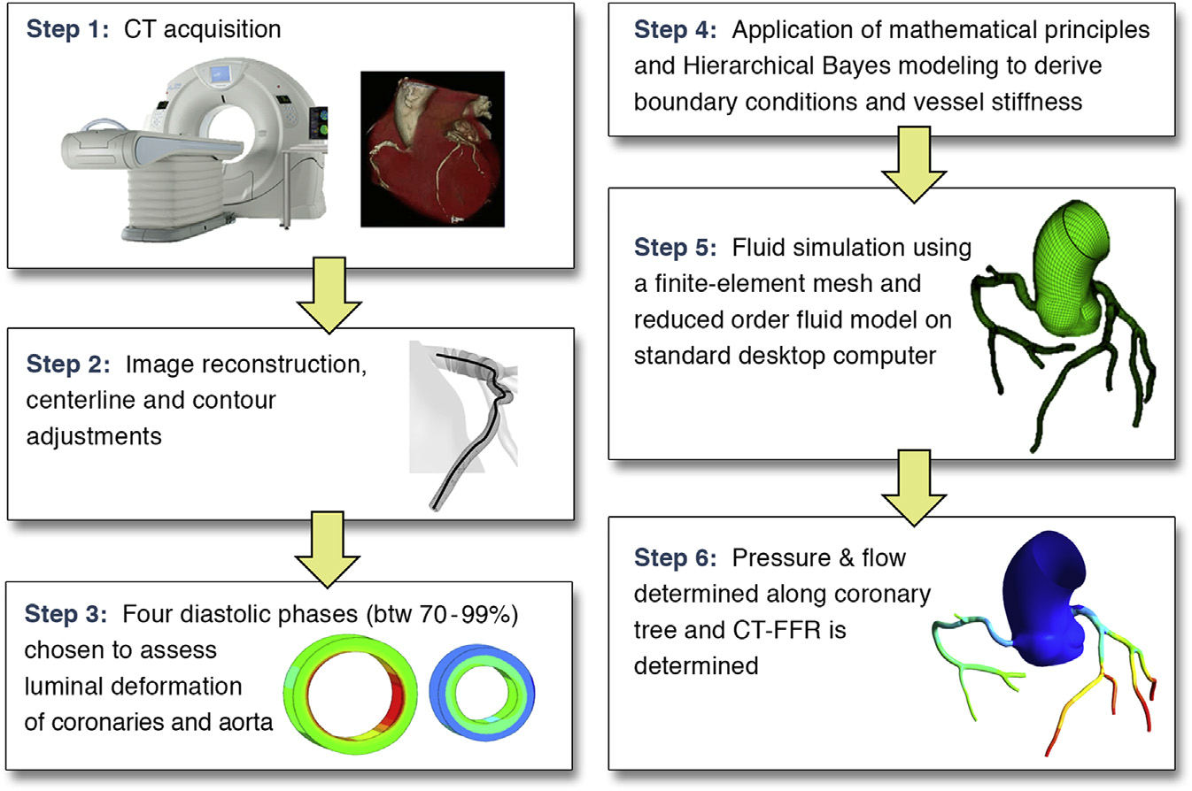

Figure 1 – Pipeline of the work

Procedures

Images of CCTA were acquired with a 256-row, 16 cm detector CT system (Revolution CT, GE Healthcare). Beta-blockers were administered if necessary. ECG gating was implemented to acquire images at diastolic phase when contrast agent was fully perfused in the coronary arteries. FFR was performed following the clinical practice guideline. FFR was measured in all cases using the VOLCANO instrument and a coronary pressure wire (PrimeWire PRES-TIGE Plus pressure Guide Wire). After calibration and equalization, the pressure wire was advanced distally to the stenosis until the pressure sensor landed in a smooth coronary segment. Hyperemia was induced by using an intravenous infusion of adenosine (140 μg/kg per min). The pull-back FFR data were recorded from the immediate down-stream of the distal stenosis to the ostium of the coronary (PressureWire, St. Jude Medical). FFR was then calculated as the ratio between mean distal pressure (mPd) and mean aortic pressure (mPa). (Eq.1).

Eq. 1

# Data Analysis

Data

This study includes retrospectively collected CCTA scans of 187 patients (age: 18 - 75 years, 145 males) acquired between 2012 and 2016. The Institutional Ethical Review Board waived the need for informed consent. All CCTA scans were acquired using an ECG-triggered step-and-shoot protocol on a 256-detector row scanner (Philips Brilliance iCT, Philips Medical, Best, The Netherlands). A tube voltage of 120 kVp and tube current between 210 and 300 mAs were used. For patients ≤ 80 kg contrast medium was injected using a flow rate of 6 mL/s for a total of 70 mL iopromide (Ultravist 300 mg I/mL, Bayer Healthcare, Berlin, Germany), followed by a 50 mL mixed contrast medium and saline (50:50) flush, and next a 30 mL saline flush. For patients > 80 kg the flow rate was 6.7 mL/s and the volumes of the boluses were 80, 67 and 40 mL, respectively. Images were reconstructed to an in-plane resolution ranging from 0.38 to 0.56 mm, and 0.9 mm thick slices with 0.45 mm spacing. In each CCTA scan, coronary arteries were tracked and their centerlines were extracted using the method previously described by Wolterink. The method tracks the visible coronary arteries, where the arterial centerlines are extracted between the ostia and the most distal visible locations. Using the extracted centerlines, a 3D straightened MPR volumes with 0.3 mm3 isotropic resolution were reconstructed for all coronary arteries and used for further analysis. Note that we define an artery as the vessel starting from the ostium until the most distal location visible in the CCTA. B. FFR Measurements Out of the 187 patients, 137 patients suspected of obstructive CAD underwent invasive FFR measurements (0.81 ± 0.10, interquartile range: 0.74-0.89), up to one year after the acquisition of the CCTA scan. In these patients, FFR was measured in 192 different arteries. FFR was recorded with a coronary pressure guidewire (Certus Pressure Wire, St. Jude Medical, St. Paul, Minnesota) at maximal hyperemia conditions. Maximal hyperemia was induced by administration of intravenous adenosine (at a rate of 140 µg/kg per minute) through a central vein. The FFR wire was placed at the most distal part possible in the target artery. Using manual pullback, a single minimal FFR value was assessed and recorded for each artery.

Statistical Analysis

Continuous variables are mean ± SD if normally distributed. Categorical variables are frequencies (percentages). Sensitivity, speciﬁcity, positive predictive value (PPV) and NPV were calculated to predict the ability of each modality to identify functionally signiﬁcant stenoses on a per-vessel basis. The association between the studied CT technique and the FFR was assessed using a generalized estimation approach. Patient identity was included as a cluster variable to account for likely within-individual correlations, given that repeated measures were made from each individual. FFR as a dichotomous variable was assumed to have a binomial probability distribution. Interobserver and intraobserver reproducibility were performed on 16 randomly selected vessels. Receiver-operating characteristic curve (ROC) area under the curve analysis was undertaken to evaluate the discriminatory ability of coronary CTA and CT-FFR to detect FFR #0.8. The optimal CT-FFR threshold established in the derivation cohort, which provided at least 65% sensitivity and maximized the sum of sensitivity and speciﬁcity, was chosen as the threshold for the vali-dation cohort. Areas under the ROC curves were compared using the approach of DeLong et al. (16) with a Bonferroni adjustment for pair-wise compar-isons. The incremental value of CT-FFR to coronary CTA in discriminating signiﬁcant FFR was assessed by 2 methods. The integrated discrimination improvement (IDI) index and the category-free net re-classiﬁcation index (NRI) were used to determine whether CT-FFR improved vessel classiﬁcation as hemodynamically signiﬁcant compared with coronary CTA alone (17). An IDI index that is signiﬁcantly > 0 is taken to demonstrate the incremental value of the studied technique when added to coronary CTA. The NRI can be calculated by consideration of the sum of 2 separate components, vessels with FFR #0.8 and vessels with FFR >0.8. For vessels with FFR #0.8, we assigned 1 for upward reclassiﬁcation, 1 for downward reclassiﬁcation, and 0 for vessels which did not change their risk category by applying CT-FFR compared with coro-nary CTA alone. For vessels with FFR >0.80, the opposite was performed. The sum of the individual scores was divided by the number of vessels in each group. Intraobserver and interobserver variability in assessment of CT-FFR were determined using Bland-Altman analysis. Statistical analysis was performed using SPSS version 20 (SPSS, Chicago, Illinois) and STATA version 13.1 (STATA Corp., College Station, Texas) software. A p value <0.05 was considered statistically signiﬁcant.

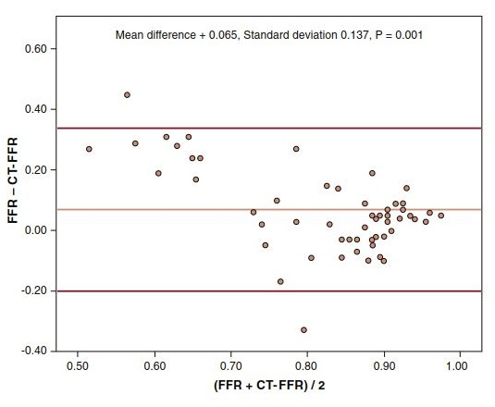

Figure 2 - Bland-Altman Plot of CT-FFR and Invasive FFR

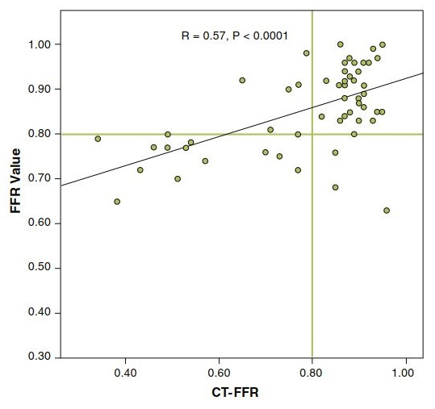

Figure 3 - Correlation Between CT-FFR and Invasive FFR

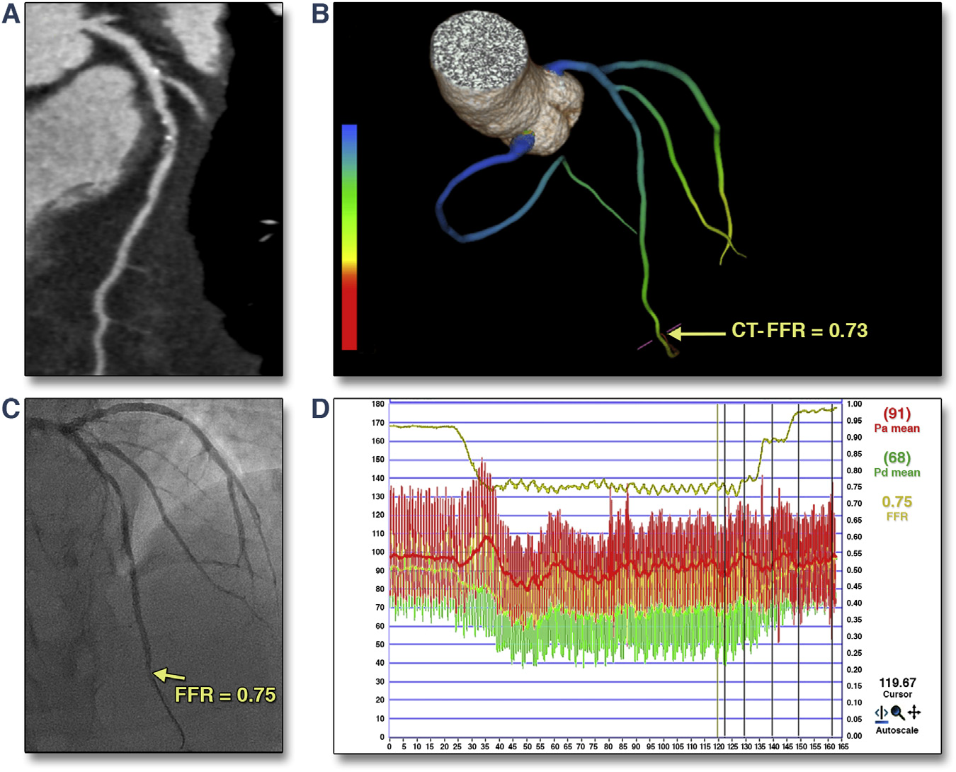

The Results you should approach

# The developing of the ML model

Evaluation

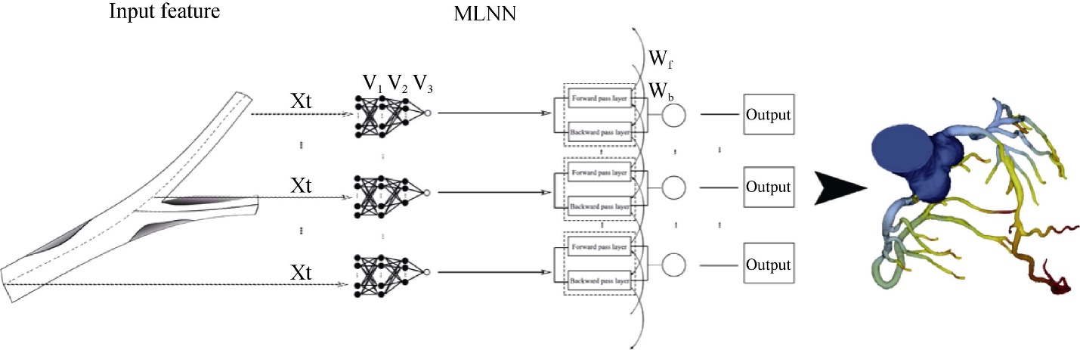

Implementation

Research of different models of the ML methods

Results

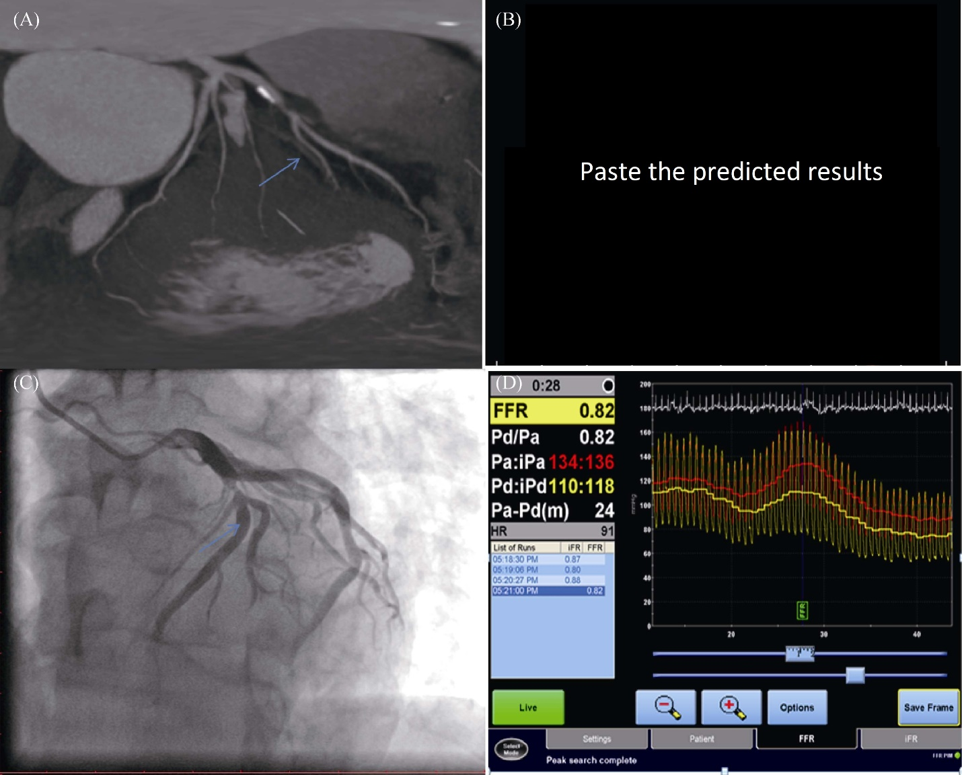

Correlation and agreement between FFR and the developed platform

Accuracy of the platform for diagnosis of ischemia-related lesions

Computational performance of the developed platform

Discussion

The CFD approach has been frequently applied to compute the FFR from CTA. This technique heavily relied on the quality of the underlying computational models and sophisticated boundary conditions and required a few hours for computation. We developed the platform using the emerging deep learning technique to calculate the FFR value from CTA images in a short period of time. The computational time of our platform for calculating the FFR value for a new case was 120 ± 13 s regardless of the configuration of the device for CCTA DICOM data storage, which is much faster than that of existing CFD models on a moderate workstation.

We demonstrated an efficient workflow for non-invasive functional assessment method for ischemic-risk of the stenotic coronary arteries. On one hand, the raw CCTA images in DICOM format of each patient was upload to the platform without conventional procedures, including pre-processing for segmentation of the arterial regions and extraction of the input features and post-processing for extraction of diagnostic index from calculations. Therefore, significant amount of time-span was spared. On the other hand, the online nature of the platform had eliminated the time expense variation associating with configuration of the local processer device. In additional to the fast prediction manner of deep learning algorithm, the platform could be clinically suitable solution for CAD screening.

A Meta-analysis included 908 vessels from 536 patients in five studies was performed by Cook, *et al*. The overall per-vessel diagnostic accuracy of FFR-CT was 81.9% (95% CI, 79.4%–84.4%). The overall per-vessel diagnostic accuracy of our platform was over …%. We also observed the improvement of the platform in detecting ischemic-risk compared to using CTA alone.